Name Period
Learning Objectives
2.9 I can represent graphically or model quantitatively the exchange of molecules between an organism and its environment, and the subsequent use of these molecules to build new molecules that facilitate dynamic homeostasis, growth and reproduction.
2.10 I can use representations and models to pose scientific questions about the properties of cell membranes and selective permeability based on molecular structure.
2.11 I can construct models that connect the movement of molecules across membranes with membrane structure and function.
2.12 I can use representations and models to analyze situations or solve problems qualitatively and quantitatively to investigate whether dynamic homeostasis is maintained by the active movement of molecules across membranes.
Yes! This is a BIG, fascinating and important chapter!!!

Chapter 5.1-5.5: Membrane Transport

Concept 5.1 Cellular membranes are fluid mosaics of lipids and proteins

- Phospholipids are amphipathic. Explain what this means.

- The currently accepted model of the membrane is the fluid mosaic model. Describe this model.

- Describe how each of the following can affect membrane fluidity:

  - decreasing temperature

  - phospholipids with unsaturated hydrocarbon chains

  - cholesterol

- Label the following structures:

Glycolipid, glycoprotein, integral protein, peripheral protein, cholesterol, phospholipid, ECM fibers,
Cytoskeleton, microfilaments

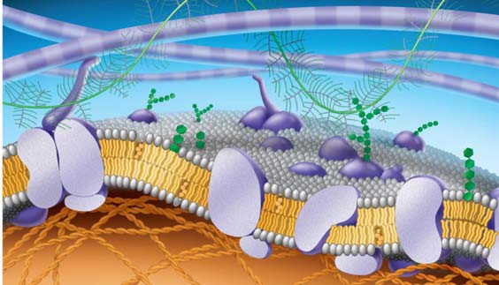

- Study Figure 5.8 to understand how new membrane is made, then do the “Draw It” exercise associated with the figure.

- Do Concept Check 5.1 #1

- Do Concept Check 5.1 “What If?”

Concept 5.2 Membrane structure results in selective permeability
- Peter Agre received the Nobel Prize in 2003 for the discovery of aquaporins. What are they (important!)?

Concept 5.3 Passive transport is diffusion of a substance across a membrane with no energy investment

- Define the following terms:

diffusion

concentration gradient

passive transport

osmosis
isotonic
hypertonic
hypotonic
turgid
flaccid
plasmolysis
- Use as many words from the list above to describe why a carrot left on the counter overnight would become limp. Underline each word you use.

- What is facilitated diffusion? Is it active or passive? Cite two examples.

- Label the hypotonic solution, isotonic solution, and hypertonic solution. What is indicated by the blue arrows? Label them. Which cell is lysed? Turgid? Flaccid? Plasmolyzed? Apply all these labels. Why doesn’t the plant cell burst like the red blood cell does?

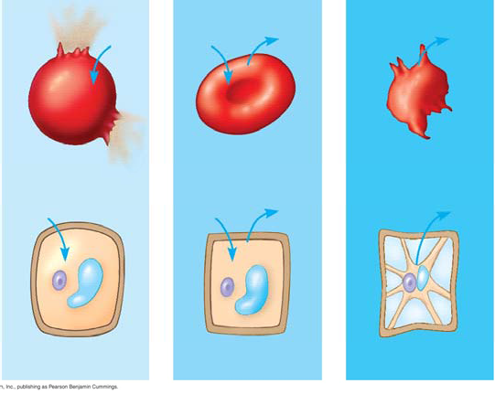

- Concept Check 5.3 What if?: If a paramecium caudatum cell swims from a hypotonic to an isotonic environment, will its contractile vacuole become more active or less? Why?

- Consider the following materials that must cross the membrane. For each, tell how it is accomplished. (may need to go back to 5.2, first paragraph.

Material | Method
CO2
glucose
H+
O2
H2O

Concept 5.4 Active transport uses energy to move solutes against their gradients

- Describe active transport. What type of transport proteins are involved, and what is the role of ATP in the process?

- The sodium-potassium pump is an important system for you to know. Use the following diagram to understand how it works. Use the following terms to label
these figures, and briefly summarize what is occurring in each figure:
extracellular fluid, cytoplasm, Na+, K+, ATP, ADP, P, transport protein.
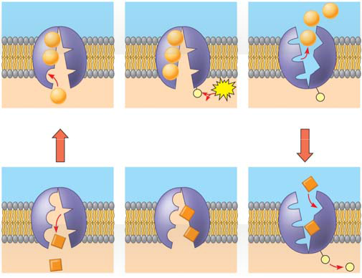

Summary
1.
2.

3.

4.

5.

- On the diagram below, add these labels: facilitated diffusion with a carrier protein, facilitated diffusion with a channel protein, active transport with a carrier protein, simple diffusion. For each type of transport, give an example of a material that is moved in this manner.

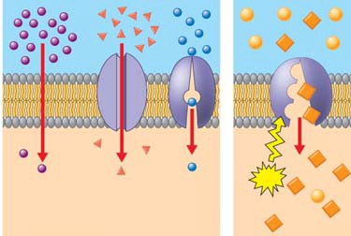

- What is membrane potential? Which side of the membrane is positive?

- What are the two forces that drive the diffusion of ions across the membrane? What is the combination of these forces called?

- What is cotransport? Explain how understanding it is used in our treatment of diarrhea.

Concept 5.5 Bulk transport across the plasma membrane occurs by exocytosis and endocytosis

- Define and sketch each of the following, and give a specific cellular example.

endocytosis

exocytosis
receptor-mediated endocytosis

phagocytosis

pinocytosis
- Describe familial hypercholesterolemia. Why does it happen and what do you suppose is its basis?

Chapter 25 Active Reading Guide
The Origin and Diversification of Eukaryotes
Section 1
- What was the earliest form of life on the planet? How long ago did this life-form first occur?

- What unique ability was originated with cyanobacteria? How did this alter life on Earth and lead to a wave of mass extinctions?

- The first eukaryotes did not appear until approximately 2.1 billion years ago. Explain the evolution of eukaryotes by endosymbiosis.

- Summarize three lines of evidence that support the model of endosymbiosis.

